DOCKERS AND HYPERVISORS

TEAM 2
J ADITYA
MILAN MENZES
AKSHATHA HEMANT
PADMASHREE S
ANUSHREE CA
CHETHAN KULKARNI

CONTENT

- ABSTRACT
- INTRODUCTION
- SECURITY PROBLEM IN DOCKERS
- SECURITY PROBLEMS IN HYPERVISORS
- SECURITY API
- SUMMARY
- REFERENCES
- APENDIX

INTRODUCTION

WHAT IS HYPERVISOR (VM)?

A hypervisor or virtual machine monitor (VMM) is a piece of computer software, firmware or hardware that creates and runs virtual machines. A computer on which a hypervisor runs one or more virtual machines is called a host machine, and each virtual machine is called a guest machine. The hypervisor presents the guest operating systems with a virtual operating platform and manages the execution of the guest operating systems. Multiple instances of a variety of operating systems may share the virtualized hardware resources: for example, Linux, Windows, and OS X instances can all run on a single physical x86 machine. This contrasts with operating-system-level virtualization, where all instances (usually called containers) must share a single kernel, though the guest operating systems can differ in user space, such as different Linux distributions with the same kernel.

Classification
There are two type of hypervisors:
1.Type-1, native or bare-metal hypervisors
2.Type-2 or hosted hypervisors
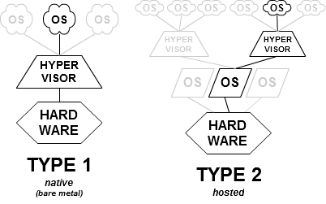

1.Type-1 Hypervisors
These hypervisors run directly on the host's hardware to control the hardware and to manage guest operating systems. For this reason, they are sometimes called bare metal hypervisors. The first hypervisors, which IBM developed were native hypervisors.These included the test software SIMMON and the CP/CMS operating system. Modern equivalents include Oracle VM server for SPARC, Oracle VM server for x86, Microsoft HYPER-V and VMware ESX/ESXi.

2.Type-2 Hypervisors

These hypervisors run on a conventional operating system just as other computer programs do. A guest operating system runs as a process on the host. Type-2 hypervisors abstract guest operating systems from the host operating system. VMware Workstation, VMware Player, VirtualBox, Parallels Desktop for Mac and QEMU are examples of type-2 hypervisors.

WHAT IS DOCKERS?

Docker is an open-source project that automates the deployment of Linux applications inside software containers. Quote of features from Docker web pages:
Docker containers wrap up a piece of software in a complete filesystem that contains everything it needs to run: code, runtime, system tools, system libraries – anything you can install on a server. This guarantees that it will always run the same, regardless of the environment it is running in.
Docker provides an additional layer of abstraction and automation of operating-system-level virtualization on Linux.[6] Docker uses the resource isolation features of the Linux kernel such as cgroups and kernel namespaces, and a union-capable file system such as aufs and others to allow independent "containers" to run within a single Linux instance, avoiding the overhead of starting and maintaining virtual machines.
The Linux kernel's support for namespaces mostly isolates an application's view of the operating environment, including process trees, network, user IDs and mounted file systems, while the kernel's cgroups provide resource limiting, including the CPU, memory, block I/O and network. Since version 0.9, Docker includes the libcontainer library as its own way to directly use virtualization facilities provided by the Linux kernel, in addition to using abstracted virtualization interfaces via libvirt, LXC (Linux Containers) and systemd-nspawn
Containers running on a single machine share the same operating system kernel; they start instantly and use less RAM. Images are constructed from layered filesystems and share common files, making disk usage and image downloads much more efficient.
Docker containers are based on open standards, enabling containers to run on all major Linux distributions and on Microsoft Windows -- and on top of any infrastructure.
Containers isolate applications from one another and the underlying infrastructure, while providing an added layer of protection for the application.

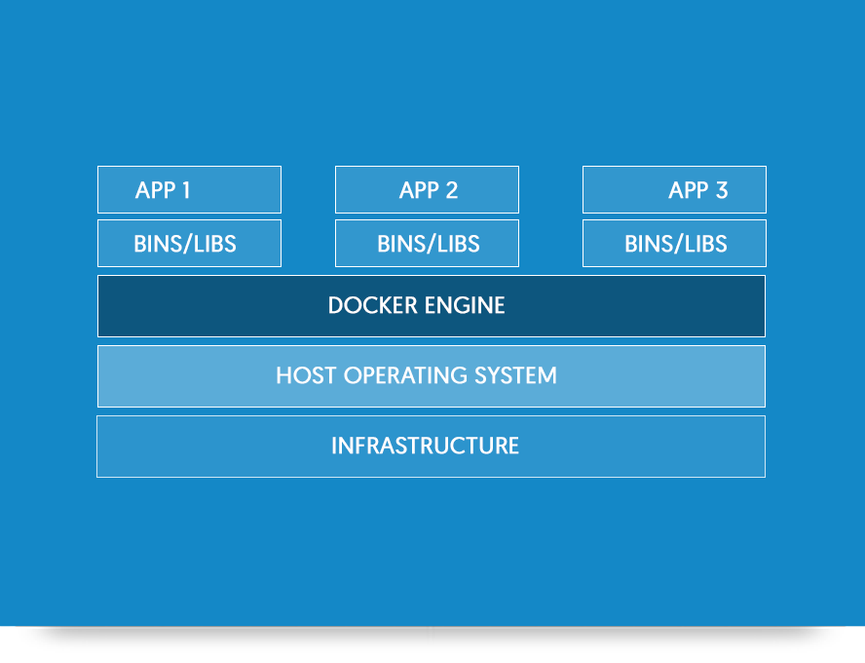

DOCKER VERSUS VM

- VMs take up a lot of system resources. Each VM runs not just a full copy of an operating system, but a virtual copy of all the hardware that the operating system needs to run. This quickly adds up to a lot of RAM and CPU cycles.

- But all that a container requires is enough of an operating system, supporting programs and libraries, and system resources to run a specific program.

- containers can enable our company to pack a lot more applications into a single physical server than a virtual machine (VM) can. Container technologies, such as Docker, beat VMs at this part of the cloud or data-center game.

- More Applicaions can be used in a single server in dockers in comparison to VM.

- With containers we can create a portable, consistent operating environment for development, testing, and deployment.

- We can use containers to run a single application and VMs to run multiple applications.

- If we need to run the maximum amount of particular applications on a minimum of servers. then we can use containers -- keeping in mind that we are going to need to have a close eye on our systems running containers until container security is locked down.
- If we need to run multiple applications on servers and/or have a wide variety of operating systems we will want to use VMs.
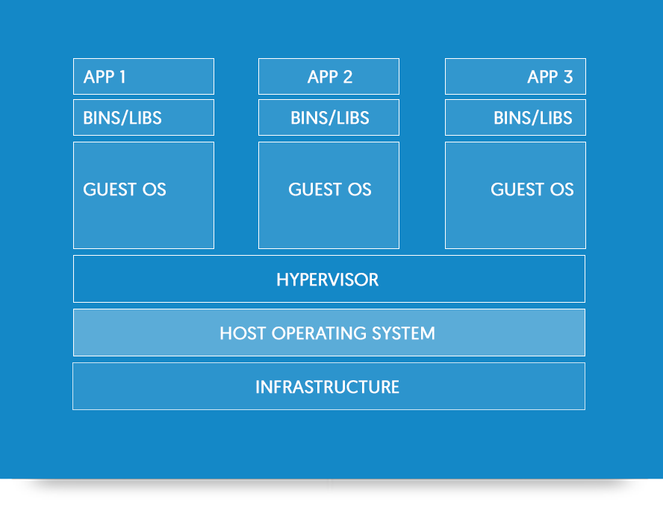

SECURITY ISSUES

Security in containers / dockers.

Libcontainers accesses five namespaces -- Process, Network, Mount, Hostname, and Shared Memory -- to work with Linux,But there's a lot of important Linux kernel subsystems outside the container.These include all devices, SELinux, Cgroups and all file systems under /sys. This means if a user or application has superuser privileges within the container, the underlying operating system could, in theory, be cracked.

There are many ways to secure Docker and other container technologies. For example, we can mount a /sys file system as read-only, force container processes to write only to container-specific file systems, and set up the network namespace so it only connects with a specified private intranet and so on. But, none of this is built in by default. It takes sweat to secure containers.
The basic rule is that we need to treat containers the same way you would any server application. That is, as Walsh spells out:
- Drop privileges as quickly as possible
- Run our services as non-root whenever possible
- Treat root within a container as if it is root outside of the container
Another security issue is that many people are releasing containerized applications. Now, some of those are worse than others.

Docker security
There are four major areas to consider when reviewing Docker security:
- The intrinsic security of the kernel and its support for namespaces and cgroups;
- The attack surface of the Docker daemon itself;
- Loopholes in the container configuration profile, either by default, or when customized by users.
- The “hardening” security features of the kernel and how they interact with containers.

Kernel namespaces
Docker containers are very similar to LXC containers, and they have similar security features. When we start a container with docker run, behind the scenes Docker creates a set of namespaces and control groups for the container.
Namespaces provide the first and most straightforward form of isolation: processes running within a container cannot see, and even less affect, processes running in another container, or in the host system.
Each container also gets its own network stack, meaning that a container doesn’t get privileged access to the sockets or interfaces of another container. Of course, if the host system is setup accordingly, containers can interact with each other through their respective network interfaces — just like they can interact with external hosts. When we specify public ports for our containers or use links then IP traffic is allowed between containers. They can ping each other, send/receive UDP packets, and establish TCP connections, but that can be restricted if necessary. From a network architecture point of view, all containers on a given Docker host are sitting on bridge interfaces. This means that they are just like physical machines connected through a common Ethernet switch; no more, no less.
Namespace code has been exercised and scrutinized on a large numbe
r of production systems. And there is more: the design and inspiration for the namespaces code are even older. Namespaces are actually an effort to reimplement the features of OpenVZ in such a way that they could be merged within the mainstream kernel. And OpenVZ was initially released in 2005, so both the design and the implementation are pretty mature.

Control groups
Control Groups are another key component of Linux Containers. They implement resource accounting and limiting. They provide many useful metrics, but they also help ensure that each container gets its fair share of memory, CPU, disk I/O; and, more importantly, that a single container cannot bring the system down by exhausting one of those resources.
So while they do not play a role in preventing one container from accessing or affecting the data and processes of another container, they are essential to fend off some denial-of-service attacks. They are particularly important on multi-tenant platforms, like public and private PaaS, to guarantee a consistent uptime (and performance) even when some applications start to misbehave.
Control Groups have been around for a while as well: the code was started in 2006, and initially merged in kernel 2.6.24.

Docker daemon attack surface
Running containers (and applications) with Docker implies running the Docker daemon. This daemon currently requires root privileges, and we should therefore be aware of some important details.
First of all, only trusted users should be allowed to control our Docker daemon. This is a direct consequence of some powerful Docker features. Specifically, Docker allows we to share a directory between the Docker host and a guest container; and it allows us to do so without limiting the access rights of the container. This means that we can start a container where the /host directory will be the / directory on our host; and the container will be able to alter our host filesystem without any restriction. This is similar to how virtualization systems allow filesystem resource sharing. Nothing prevents you from sharing our root filesystem (or even our root block device) with a virtual machine.
This has a strong security implication: for example, if you instrument Docker from a web server to provision containers through an API, you should be even more careful than usual with parameter checking, to make sure that a malicious user cannot pass crafted parameters causing Docker to create arbitrary containers.
For this reason, the REST API endpoint (used by the Docker CLI to communicate with the Docker daemon) changed in Docker 0.5.2, and now uses a UNIX socket instead of a TCP socket bound on 127.0.0.1 (the latter being prone to cross-site request forgery attacks if you happen to run Docker directly on our local machine, outside of a VM). You can then use traditional UNIX permission checks to limit access to the control socket.
You can also expose the REST API over HTTP if you explicitly decide to do so. However, if you do that, being aware of the above mentioned security implication, you should ensure that it will be reachable only from a trusted network or VPN; or protected with e.g., stunnel and client SSL certificates. You can also secure them with HTTPS and certificates.
The daemon is also potentially vulnerable to other inputs, such as image loading from either disk with ‘docker load’, or from the network with ‘docker pull’. As of Docker 1.3.2, images are now extracted in a chrooted subprocess on Linux/Unix platforms, being the first-step in a wider effort toward privilege separation. As of Docker 1.10.0, all images are stored and accessed by the cryptographic checksums of their contents, limiting the possibility of an attacker causing a collision with an existing image.
Eventually, it is expected that the Docker daemon will run restricted privileges, delegating operations well-audited sub-processes, each with its own (very limited) scope of Linux capabilities, virtual network setup, filesystem management, etc. That is, most likely, pieces of the Docker engine itself will run inside of containers.
Finally, if you run Docker on a server, it is recommended to run exclusively Docker in the server, and move all other services within containers controlled by Docker. Of course, it is fine to keep our favorite admin tools (probably at least an SSH server), as well as existing monitoring/supervision processes, such as NRPE and collectd.

Linux kernel capabilities
By default, Docker starts containers with a restricted set of capabilities. What does that mean?
Capabilities turn the binary “root/non-root” dichotomy into a fine-grained access control system. Processes (like web servers) that just need to bind on a port below 1024 do not have to run as root: they can just be granted the net_bind_service capability instead. And there are many other capabilities, for almost all the specific areas where root privileges are usually needed.
This means a lot for container security; let’s see why!
our average server (bare metal or virtual machine) needs to run a bunch of processes as root. Those typically include SSH, cron, syslogd; hardware management tools (e.g., load modules), network configuration tools (e.g., to handle DHCP, WPA, or VPNs), and much more. A container is very different, because almost all of those tasks are handled by the infrastructure around the container:
- SSH access will typically be managed by a single server running on the Docker host;
- cron, when necessary, should run as a user process, dedicated and tailored for the app that needs its scheduling service, rather than as a platform-wide facility;
- log management will also typically be handed to Docker, or by third-party services like Loggly or Splunk;
- hardware management is irrelevant, meaning that you never need to run udevd or equivalent daemons within containers;
- network management happens outside of the containers, enforcing separation of concerns as much as possible, meaning that a container should never need to perform ifconfig, route, or ip commands (except when a container is specifically engineered to behave like a router or firewall, of course).
This means that in most cases, containers will not need “real” root privileges at all. And therefore, containers can run with a reduced capability set; meaning that “root” within a container has much less privileges than the real “root”. For instance, it is possible to:
- deny all “mount” operations;
- deny access to raw sockets (to prevent packet spoofing);
- deny access to some filesystem operations, like creating new device nodes, changing the owner of files, or altering attributes (including the immutable flag);
- deny module loading;
- and many others.
This means that even if an intruder manages to escalate to root within a container, it will be much harder to do serious damage, or to escalate to the host.
This won’t affect regular web apps; but malicious users will find that the arsenal at their disposal has shrunk considerably! By default Docker drops all capabilities except those needed, a whitelist instead of a blacklist approach. You can see a full list of available capabilities in Linux manpages.
One primary risk with running Docker containers is that the default set of capabilities and mounts given to a container may provide incomplete isolation, either independently, or when used in combination with kernel vulnerabilities.
Docker supports the addition and removal of capabilities, allowing use of a non-default profile. This may make Docker more secure through capability removal, or less secure through the addition of capabilities. The best practice for users would be to remove all capabilities except those explicitly required for their processes.

Other kernel security features
Capabilities are just one of the many security features provided by modern Linux kernels. It is also possible to leverage existing, well-known systems like TOMOYO, AppArmor, SELinux, GRSEC, etc. with Docker.
While Docker currently only enables capabilities, it doesn’t interfere with the other systems. This means that there are many different ways to harden a Docker host. Here are a few examples.
- You can run a kernel with GRSEC and PAX. This will add many safety checks, both at compile-time and run-time; it will also defeat many exploits, thanks to techniques like address randomization. It doesn’t require Docker-specific configuration, since those security features apply system-wide, independent of containers.
- If our distribution comes with security model templates for Docker containers, you can use them out of the box. For instance, we ship a template that works with AppArmor and Red Hat comes with SELinux policies for Docker. These templates provide an extra safety net (even though it overlaps greatly with capabilities).
- You can define our own policies using our favorite access control mechanism.
Just like there are many third-party tools to augment Docker containers with e.g., special network topologies or shared filesystems, you can expect to see tools to harden existing Docker containers without affecting Docker’s core.
As of Docker 1.10 User Namespaces are supported directly by the docker daemon. This feature allows for the root user in a container to be mapped to a non uid-0 user outside the container, which can help to mitigate the risks of container breakout. This facility is available but not enabled by default.
Refer to the daemon command in the command line reference for more information on this feature. Additional information on the implementation of User Namespaces in Docker can be found in this blog post.

Conclusions

Docker containers are, by default, quite secure; especially if we take care of running our processes inside the containers as non-privileged users (i.e., non-root).
We can add an extra layer of safety by enabling AppArmor, SELinux, GRSEC, or our favourite hardening solution.
Last but not least, if we see interesting security features in other containerization systems, these are simply kernels features that may be implemented in Docker as well. We welcome users to submit issues, pull requests, and communicate via the mailing list.

REFERENCES

https://www.docker.com/

Youtube

